The Computational Modeling of Type IV Pili Carbohydrate Side Chain

By

Xiaotong Zuo

A thesis submitted to the Johns Hopkins University in conformity with the

Requirements of the degree of Master of Science and Engineering

*Baltimore, Maryland*

*May 2016*

*Copyright Xiaotong Zuo, 2016*

*All rights reserved*

# ABSTRACT

Type IV pili are extracellular filamentous adhesive appendages which are assembled from the protein monomer, called pilin. Type IV pili provide several properties to the bacteria including twitching motility (9), horizontal gene-transfer (10), host-cell adhesion (11) and microcolony/biofilm formation (12). Besides these properties, type IV pili are also the main virulent factor of the bacteria. It has been proved that the glycosylation of the pilin was an important source of bacteria virulence.

In order to see how does the carbohydrate side chain influence the conformation and virulence of the pilin, I modeled the terminal carbohydrate side chain along with the terminal amino acids of two types of pilin, called pilin ACICU and pilin M2.

Rosetta is a comprehensive software suite for modeling macromolecular structures. As a flexible, multi-purpose application, it includes tools for structure prediction, design, and remodeling of proteins and nucleic acids.

Rosetta began as a structure prediction tool, and has consistently been a strong performer in the Critical Assessment of Structure Prediction (CASP) community-wide blind prediction exercises. It has grown to offer a wide variety of effective sampling algorithms to explore backbone, side-chain and sequence space, and its excellence has generalized to more community-wide exercises including RNA-puzzles and Critical Assessment of PRotein Interactions (CAPRI). Rosetta boasts broadly tested scoring (energy) functions and contains an unparalleled breadth of applications from folding to docking to design.

Advisor: Dr. Jeffrey J. Gray

# ACKNOWLEDGMENTS

I wish to express my sincere gratitude for my advisor, Dr. Jeffrey J. Gray, who has always support me throughout this research project. His steady guidance and encouragements were extremely important in bring this research project to completion.

I also wish to express my appreciation to my collaborator, Dr. Eric J. Sundberg and Dr. Kurt H. Piepenbrink from the School of Medicin at the University of Maryland

I wish to thank Dr. for serving as a reader in my master thesis,

# TABLE OF CONTENTS

Abstract

Acknowledgments

List of Figures

List of Tables

Glycan type

Sasa

Chapter I: Introduction

Chapter II: Methods

Chapter III: Results

Chapter IV: Discussion

Chapter IV: Conclusion

References

# LIST OF FIGURES

# LIST OF TABLES

**CHAPTER I**

# **INTRODUCTION**

**Type IV Pilus,Pilin, PilA, ACICU, M2 (2 pages)**

## Pilus

infection

Major vs minor

Pilus function

classification，n.m,n.g,a.b…

How to evade immune system? Variable come from: Seq diversity and glycosylation

Class I and ii pilus (N.m specific).

Glycosylation process

ACICU

M2

Pilus structure

Type IV pili are extracellular filamentous adhesive appendages expressed by both Gram-negative (3,4), and Gram-positive (5-7) bacteria, as well as archaea (8). They are primarily assembled from protein subunits, called pilin (1). Type IV pilins are small (~7-20 kDa) structural proteins with a conserved hydrophobic α-helical N terminus that is both a transmembrane domain and a protein-protein interaction domain.

Major and minor pilin

In contrast, within a given species, the minor pilins are typically well-conserved. Only the major pilin is highly variable (13-15) and then only in those regions left exposed in the assembled pilus (16).

Type IV pili provide several properties to the bacteria including twitching motility (9), horizontal gene-transfer (10), host-cell adhesion (11) and microcolony/biofilm formation (12). Besides these properties, type IV pili are also the main virulent factor of the bacteria. The efficacy of the bacteria to proliferate in the blood during productive infection depends on its ability to evade type IV pili specific antibodies. There are two sources of the pilin virulence. The virulence of the pilin can be diversified by transferring DNA from the silent cassettes to the expression locus to generate multiple different antigens. Another source of antigenic variation is the post translational modification, and in particular, glycosylation. It has been recognized that the class II pilin in *Neisseria meningitidis* [11, 12] were lack of gene conversion while they could successfully evade the immune system, which proved that another main source of pilin virulence be glycosylation.

Pilus, Pilin, PilA

from *A. baumannii* ACICU and *A. nosocomialis* M2, ACICU, M2

*Acinetobacter baumannii* is a Gram-negative, opportunistic pathogen.

*A. baumannii* ACICU (also known as H34) is an epidemic, multi-drug resistant strain belonging to the European clone II group; which was isolated in an outbreak in Rome in 2005 (42)

A.n=A.b

*A. baumannii* M2 (32,43,44) was isolated in 1996 from a hip infection of a patient at Cleveland MetroHealth Systems (Cleveland, OH).

*N. gonorrhoeae* Type IV pilus filament (Protein Data Bank ID ‘2HIL’)

*P. aeruginosa* PAK pilin (donate seq, different disulfide bond positions comparing to ACICU)

PilAACICU contains two disulfide bonds; one, between residues 123 and 136, is the C-terminal disulfide bond, which is nearly universal in type IV pili from Gram-negative bacteria and the other, between residues 74 and 91, spans the first two strands of the central β-sheet (Figure 2B). However we note that this additional disulfide bond in PilAACICU does not result in any substantial rearrangement of the protein backbone.

Unlike PilAACICU, PilA M2 contains only a single disulfide bond, between residues 56 and 86, in the αβ-loop and the first strand of the β-sheet, respectively, rather than a disulfide bond at the C-terminus of the pilin headgroup (Figure 4A). The addition of covalent disulfide bonds is typically understood to be a mechanism of stabilization in polypeptides and hence the C-terminal disulfide bond which is nearly ubiquitous in type IV pilins is thought to be conserved as a mechanism to stabilize the pilin fold (48).

Virulence (2 pages)

because pili are prominent surface structures, they also are occasionally targets of host defenses, and alternating induction and shutoff of pilus expression allows for successful evasion of the immune system.

Glycan Modification will influence the …

## Rosetta Modeling

Rosetta is a comprehensive software suite for modeling macromolecular structures. As a flexible, multi-purpose application, it includes tools for structure prediction, design, and remodeling of proteins and nucleic acids.

Rosetta began as a structure prediction tool, and has consistently been a strong performer in the Critical Assessment of Structure Prediction (CASP) community-wide blind prediction exercises. It has grown to offer a wide variety of effective sampling algorithms to explore backbone, side-chain and sequence space, and its excellence has generalized to more community-wide exercises including RNA-puzzles and Critical Assessment of PRotein Interactions (CAPRI). Rosetta boasts broadly tested scoring (energy) functions and contains an unparalleled breadth of applications from folding to docking to design.

## Main goal of this thesis

1. Glycan Modeling
   1. As a major type of the post-translational modifications of proteins, glycosylation plays important on protein properties and functions. Recently, heightened attention has been drawn towards protein glycosylation in bacteria primarily because of the increasing frequency with which it is seen in pathogenic species (Benz and Schmidt, 2002; Szymanski and Wren, 2005). In particular, most glycoproteins of bacterial pathogens are either surface localized or trafficked for secretion and appear to influence interactions with the host. Prime examples of pili among Gram-negative species include pilin subunits of P. aeruginosa (Castric et al., 2001) and neisserial type IV pili (Tfp) (Stimson et al., 1995). In many instances, glycosylation-defective mutants have been shown to be attenuated in virulence- associated properties and colonization (Szymanski et al., 2002; Grass et al., 2003; Schirm et al., 2003; Hendrix- son and DiRita, 2004; Arora et al., 2005).
   2. Importance of glycosylation for proteins and for evading immune systems
      1. Glycosylation facilitates solubilization of pilin monomers and pilus fibres. The removal of the terminal glycan residues of the modification had no significant effect on the adhesive abilities of pili (Stimson et al. 1995, Marceau et al. 1998)
      2. The role of pili in mediating bacteriacal interaction has been well characterized, especially in capsulated bacteria.
   3. Glycan

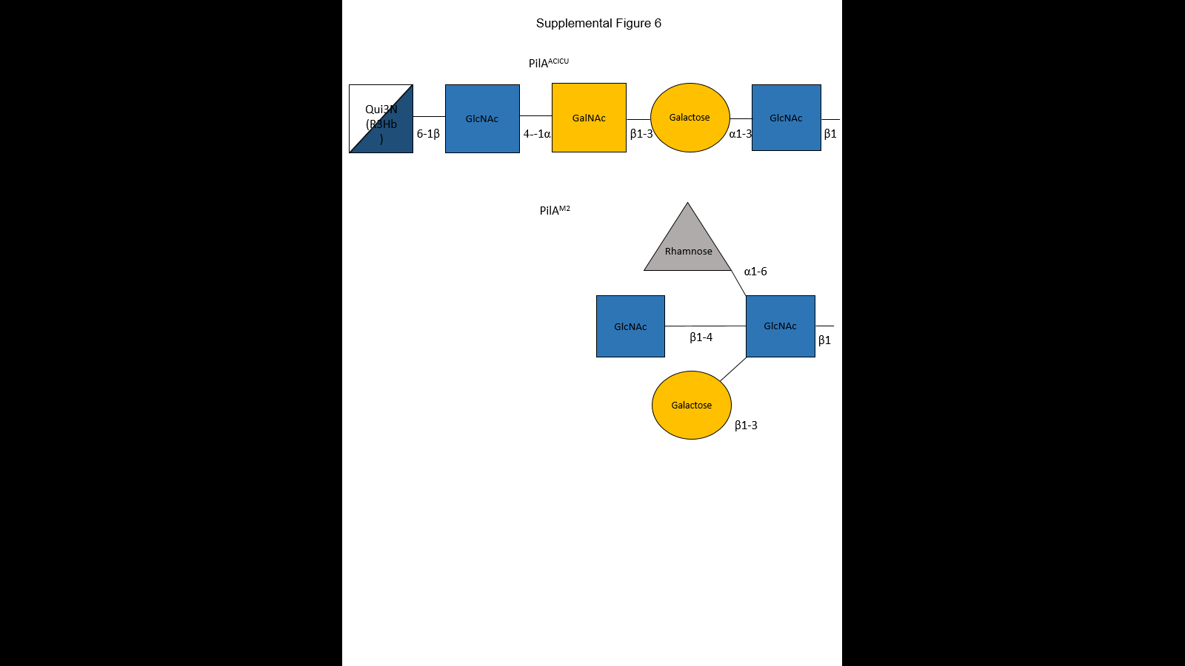

The terminal glycan residues have been linked to the terminal serine (Ser 139) of the ACICU pilin. This glycan chain was comprised of an N-Acetylglucosamine (GlcNAc), a galactose, an N-Acetylgalactosamine (GalNAc), an N-Acetylglucosamine (GlcNAc) and a 6-deoxy glucose called quinovose with its R3Hb side chain.

For the M2 pilin, the terminal glycan residues have been linked to the terminal serine (Ser 136) of the M2 pilin. Unlike the string-like glycan chain of pilin ACICU, the glycan chain of M2 had a compact globular conformation started with an N-Acetylglucosamine (GlcNAc). A galactose, an N-Acetylglucosamine (GlcNAc), and a L-Rhamnose were linked to the GlcNAc at the 3rd carbon, the 4th carbon and the 6th carbon respectively.

Since the carbohydrate side chains for both structures were linked to the terminal animo acids of the protein monomers, I modeled the carbohydrate side chain along with the terminal amino acids (so-called ‘tail’ region) after the last α-helice.

For pilin ACICU, the tail region was from residue 118 to residue Ser 139. For pilin M2, the tail region was from residue 125 to residue Ser 136.

* + 1. In both cases…FloppyTail Algorithm
  1. PyRosetta modeling introduction
     1. PyRosetta is a Python-based interactive platform for the protein structure prediction and design. It can manipulate the conformations of proteins and ligands, calculate energies of structures, and
  2. Stuff specific for glycan modeling, non-low-res, different energy weight and movemap?

**CHAPTER II**

# **METHODS**

To measure the extent to which C-terminal glycosylation of PilAACICU and PilAM2 would mask the pilin protein from binding, we modelled the full length pilins and pilus fibers and measured the effect of glycosylation on the accessible surface area of each protein in its native context. We modelled an ensemble of each glycan based on the repeating unit of the major polysaccharide glycan and minimized each structure using PyRosetta. The ten best-scoring glycan conformations were then combined to approximate the native conformational ensemble. We then measured the differences in accessible surface area using a 10Å particle probe to approximate the surface area needed for protein binding. The resulting models are shown in Figure 6 and the change in accessible surface area for each protein in Figure 7. In both cases, C-terminal glycosylation significantly reduces the surface area available for antibody binding. While the total area masked by the glycan is similar for the two structures, it is distributed differently between the two; all of the buried surface area for the ACICU glycan is contained within a single subunit while in the case of the M2 glycan, it is split between two neighboring subunits.

## InitialStructure Generating

The initial structures of PilA ACICU and M2 were modeled using the full-length *P. aeruginosa* PAK pilin (45). The initial models of the pili were created by superimposition onto a model of the *N. gonorrhoeae* Type IV pilus filament (Protein Data Bank ID ‘2HIL’) (47), and adjustment of the N-terminal helix position to eliminate clashes between subunits. The resulting models then underwent rigid-body minimization by UCSF Chimera (66). And adjusted in the Discovery Studio Visualizer (Dassault Systèmes BIOVIA, Discovery Studio Modeling Environment, Release 4.5, San Diego: Dassault Systèmes, 2015.).

## Computational Model

## Glycan Modelling Algorithm

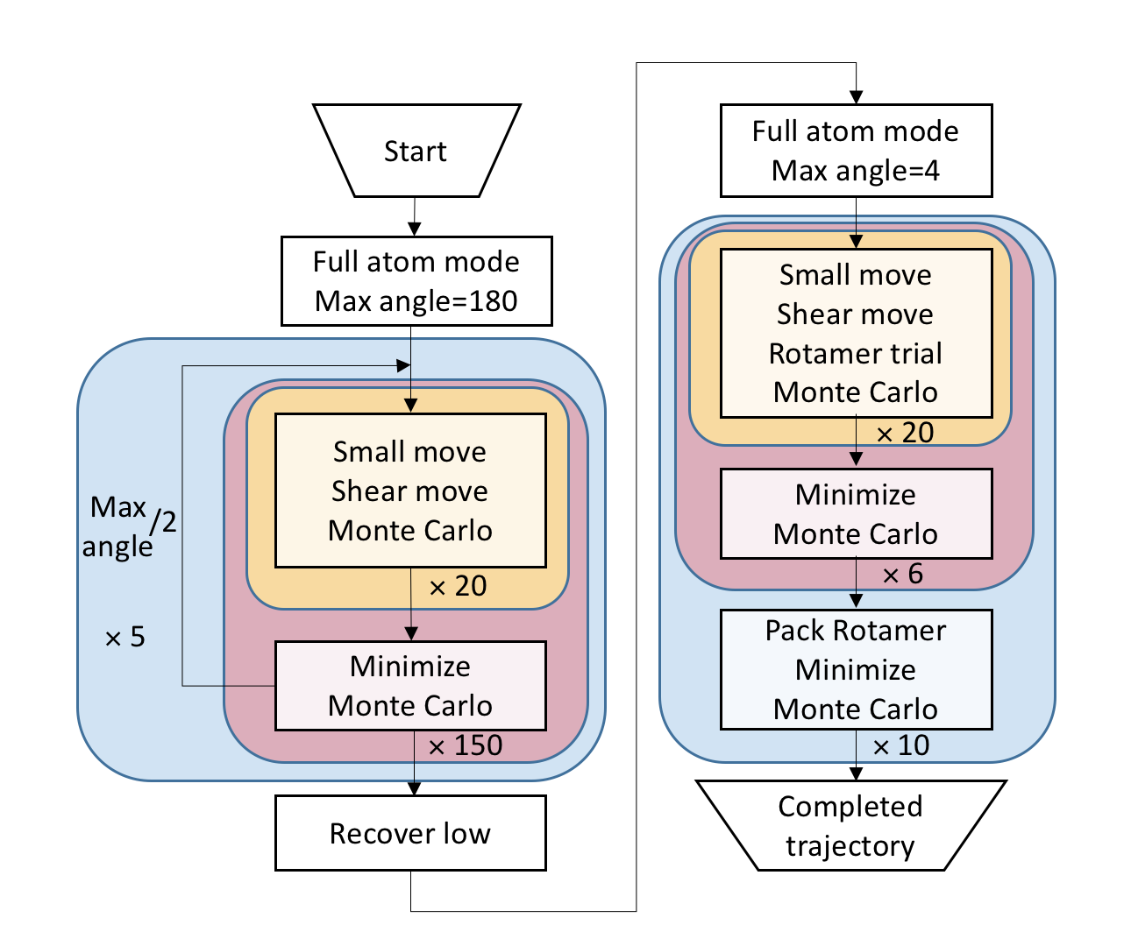

* 1. Low-resolution Gradient-based modeling

Monte Carlo

[Chapter 4 (Monte Carlo methods) of M. P. Allen & D. J. Tildesley, *Computer Simulation of Liquids*, Oxford University Press, 1989.

Z. Li & H. A. Scheraga, “Monte Carlo-minimization approach to the multiple-minima problem in protein folding,” *Proc. Natl. Acad. Sci. USA* **84**, 6611-6615 (1987).]

Torsion angle

Rotamer and repacking

Minimization

Score: reu

* 1. High-Resolution Rotamer Repacking
     1. Rotamers are a library of the most likely, low energy side chain conformations which are used to pack side chains in a rational way. In the high-resolution step, there were two tough tasks: side chain packing and rotamer packing, which were the main factors of increasing the computational complexity.
     2. The low-resolution modeling stage was followed by a high-resolution refinement stage, where the lowest energy structure from the low-resolution stage was refined by side chain packing, swapping rotamers of a random residue, torsion angle perturbation and test each move using the Metropolis criterion.

[figure algorithm]

The glycans attached to PilAACICU and M2 were modeled using PyRosetta protein structural modeling suite (67). And then the glycans were modeled using the *FloppyTail* Algorithm (68). The protocol consists two parts. In the low-resolution part, a random perturbation of the torsion angles was applied. The structures were then refined in the high-resolution part by applying a more precise perturbation of the torsion angles, the side-chain packing and the minimization. With this protocol, 6000 structures of PilAACICU and 6000 structures of PilAM2 were generated. And 1000 structures without glycans were generated.

**CHAPTER III**

# **RESULTS**

1. Low-resolution modeling efficiency (1 figure)

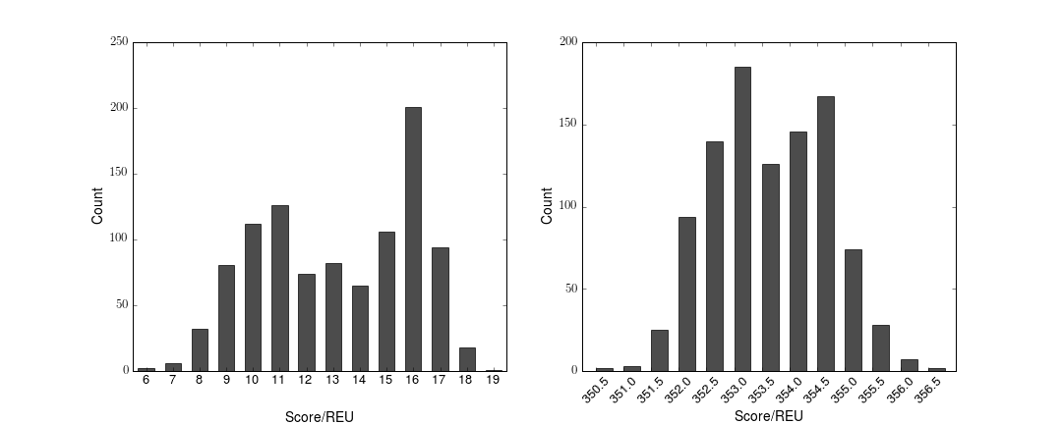To examine the searching efficiency of the low-resolution modeling step, there were 1000 decoys for ACICU and M2 generated after the low-resolution sampling ended(Fig.).

After the gradient-based low-resolution stage, the score of ACICU ranged from 6 to 19. The scores of the top 4% structures were below 8 Rosetta Energy Unit (REU), which was the top 18.9% of the score range.

The score of M2 was ranging from 350.5 to 357, which is a smaller range comparing with ACICU. The scores of the top 3% structures were below 351.5, which was the top 23.4% of the score range. The solid hydrogen bonds and short, globular glycan chain is responsible for the score ranging difference.

For both ACICU and M2, the low-resolution modeling step was efficient to find a low energy structure among the energy landscape.

1. Score with & without glycans

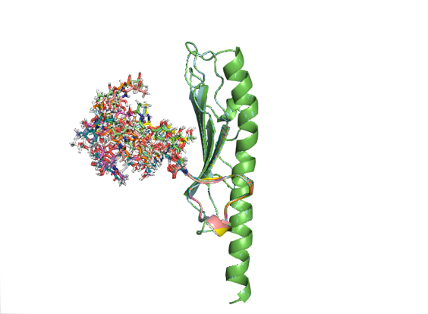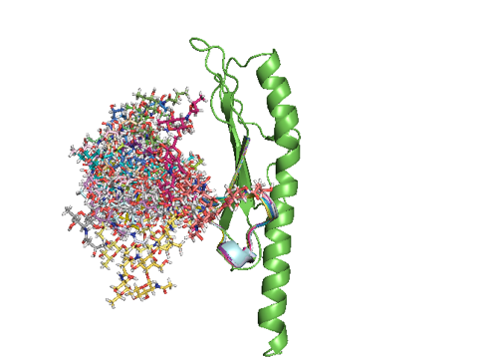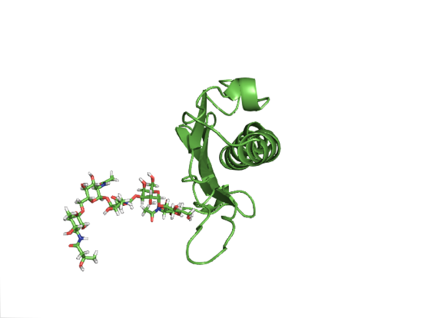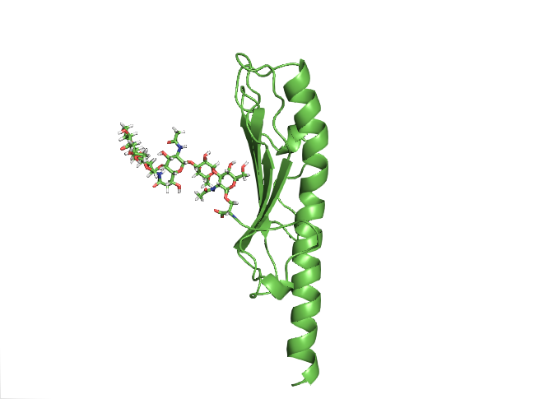

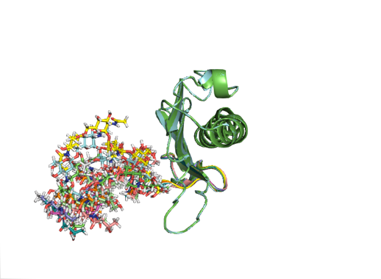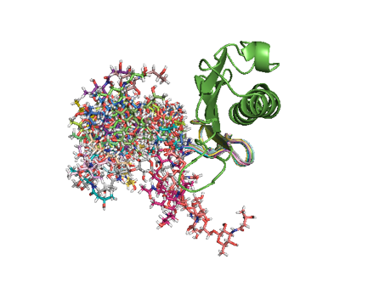

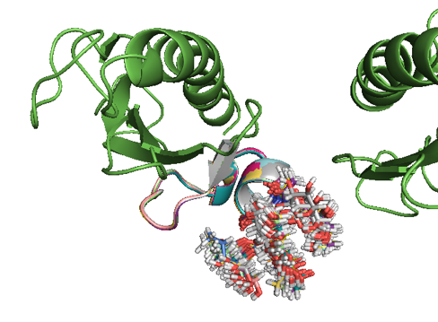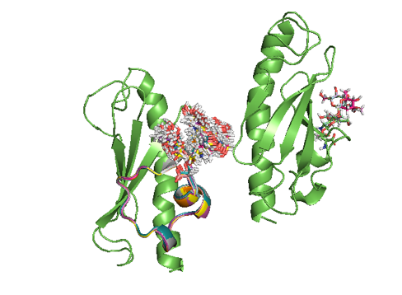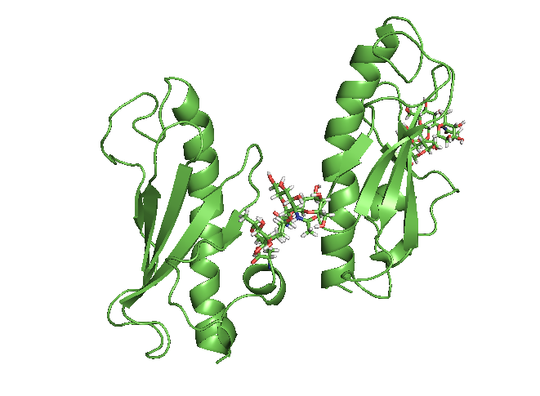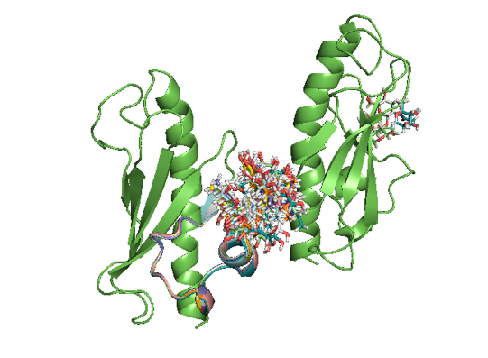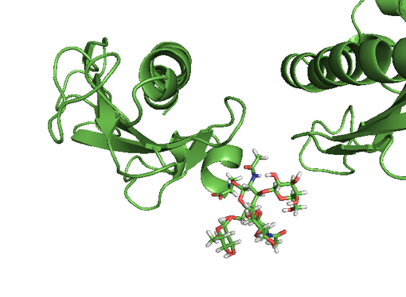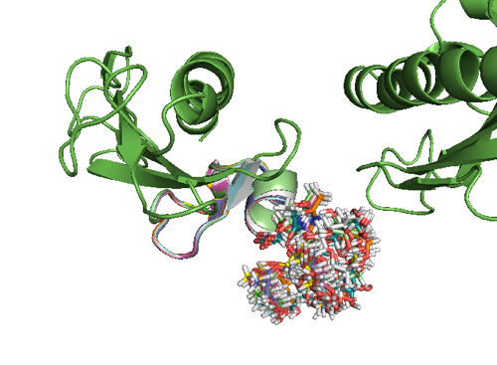

* 1. Lowest
  2. Top 10
  3. Random 20

1. Rmsd+low20decoy rmsd (Figure 2)
   1. Rmsd with carbohydrate side chain



Interestingly, there were several good structures found in ACICU which were apparently different with others. Unlike other good structures, their glycan side chains changed to an almost opposite direction at GLY 137 of the protein tail (fig). The GLY 137 of the tail region was flexible due to its highly variable torsion angle, thus resulted in totally different glycan side chain positions. However, this direction change of the glycan side chain would only be realized at the price of score increment, which was approximately 3 to 4 REU. Although the scores were slightly higher, these structures might still be the potential favored conformations as well.

[Table: torsion angle comparison]

[Figure: different conformations]

* 1. Rmsd without carbohydrate side chain

By employing the same modeling protocol, there were 1000 structures generated for each of the structures without the carbohydrate side chains. For both pilin ACICU and M2 without carbohydrates, the RMS distances had smaller ranges comparing with the former results. The lowest scores were much smaller than the ones with the carbohydrate side chains.

For pilin ACICU,

For pilin M2,



1. Hydrogen bonds

From the amino acid 132 Arg to the end of the carbohydrate side chain of pilin ACICU, there were 12 types of hydrogen bonds being observed, 5 of which existed in all the top 10 structures. These hydrogen bonds might play an important role in stabilizing the protein tail of the conformation and minimizing the energy of the structure.

From the residue 123 Asp to the ends of carbohydrate side chain of pilin M2, there were 11 types of hydrogen bonds found in the best 10 structures. As the protein terminated at residue 136 Ser, the hydrogen bonds within the protein tail were considered stable. Interestingly, for the carbohydrate side chain of pilin M2, though the four carbohydrate residues had less hydrogen bonds comparing with pilin ACICU, the only observed hydrogen bonds were found between the galactose which linked to the center glucose at the 6th carbon and the amino acids of the neighbor pilin monomer (71 Ser,93 Lys respectively). The energies for these two kinds of hydrogen bonds were -0.356 and -1.14 respectively. And the interaction with the 71 Ser was more common. These interactions between monomers might restrain the short carbohydrate side chain from moving around, and slightly contributed to the pili assembling as well.

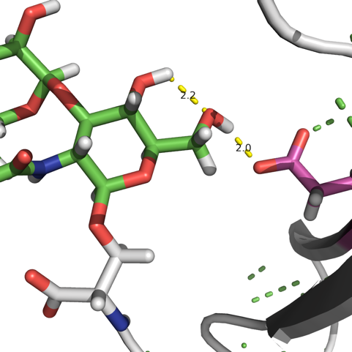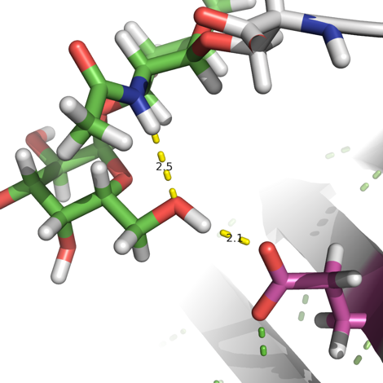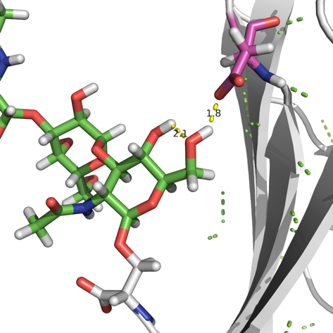

Figure: 5 types of ACICU Hydrogen bonds between the carbohydrate side chain and protein residue 105 Glu, 109 Asp.

1. 1 O4-1 O6 and 1 O6-residue 109, from lowest score decoy
2. 1-2 and 2-105
3. 1-1 and 1-105

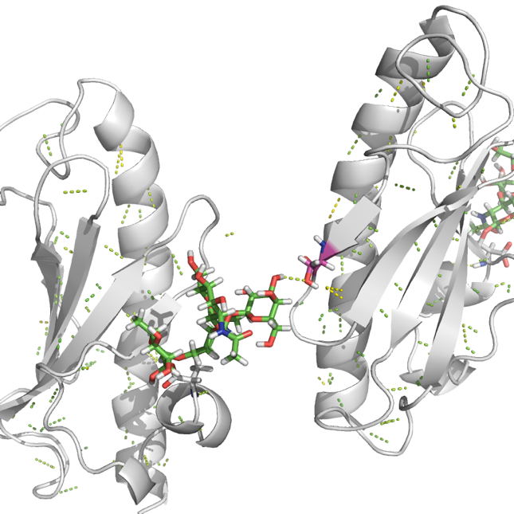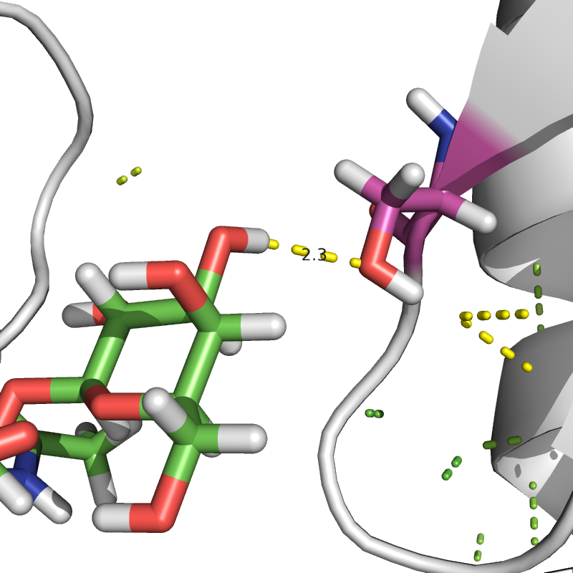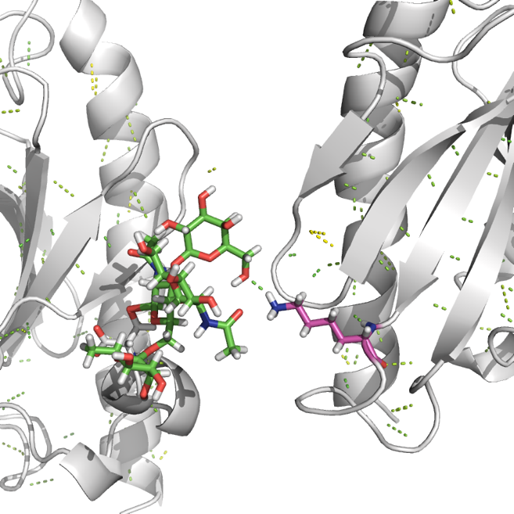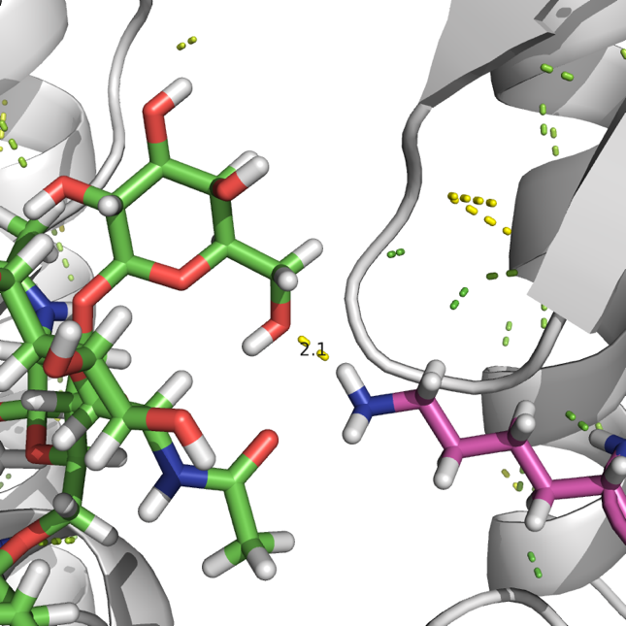

Figure: M2 Hydrogen bonds within carbohydrate side chain and the 71 Ser, 93 Lys amino acids of the neighbor monomer.

1. Resi by resi energy
   1. M2 and ACICU comparison
   2. Energy well for sugar_bb term (is resonable)
   3. Dunbrack energy
2. Surface area with & without glycans (2 Figures, 1 table)
   1. Top 10 surface

**Conclusion**

**Reference**